The Municipality of West Elgin
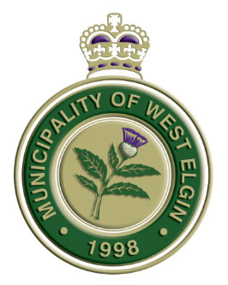
22413 Hoskins Line, Rodney, Ontario N0L 2C0

The Municipality of West Elgin has the following positions open for Student Summer Employment:
Position: General Facilities and Park Seasonal Maintenance Staff
Job Responsibilities and Requirements:
- Provide maintenance to all municipal parks and recreation facilities.
- Duties will include collection of garbage in municipal parks, cutting grass, watering flowers and other general labour duties.
- Minimum class G licence with a clean drivers abstract.
- CSA approved steel toe work boots are mandatory.
- Must work outdoors in various weather conditions.
- Successful candidates must provide a Vulnerable Sector Criminal Record Check upon hiring.
Position runs May 4, 2026, to August 28, 2026. Hours of work will be 40 hours per week with some weekend work required. Pay range is $17.60 to $19.60 per hour.

Please submit a detailed resume and cover letter outlining your qualifications by 4:00pm on Friday, February 13th, 2026, to jobs@westelgin.net.

Clearly indicate the job title when applying. For further information or the complete job description, please visit our website www.westelgin.net.

We thank all applicants for their interest in these positions; however, only those being considered for an interview will be contacted. Personal information is collected under the authority of The Municipal Freedom of Information and Protection of Privacy Act and is used for candidate selection purposes only. Accommodations are available upon request for all parts of recruitment process.

